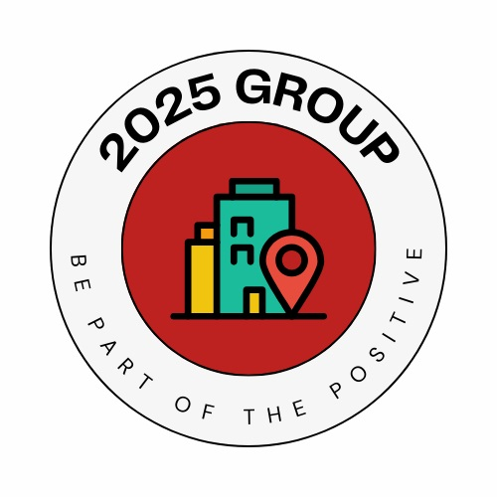

**Grimsby Town Centre**

**Activities Fund**

***The fund is now open for applications***

**Applications close at 5pm on Thursday 31st October 2024**

This grant fund is funded via the 2025 Group.

The 2025 Group is a project set up by Grimsby Retailers in Partnership CIC.

The "2025 Group" is funded by the UKSPF (UK Shared Prosperity Fund) and supports the ambitious vision laid out by North East Lincolnshire Council for Grimsby’s forthcoming transformation and revitalisation.

www.2025group.com

**About the fund**

This grant scheme is to support activities and events within and around Victoria Street in Grimsby and accepts applications from businesses, not for profit, voluntary and community organisations in North East Lincolnshire (ideally experienced in delivering activities in this area) that can clearly demonstrate how their project contributes to following:

**Target Area of Benefit:**

Projects must impact the area within and around the Victoria Street area of Grimsby

**Priorities:**

Projects should provide events and activities that address the following:

* Increase footfall into Grimsby Town Centre
* Increase engagement with town centre users

**Application Process**

Key dates:

|  |  |  |
| --- | --- | --- |
| **Application form deadlines** | **Decision date(s)** | **Results announced** |
| Rolling application process with applications accepted until Thursday  31st October 2024  5pm | Applications assessed  as they are received | Applicants will receive  a decision  within two weeks of submission |

**Grant Conditions including Monitoring and Reporting**

As soon as a signed copy of the offer letter has been returned to VANEL by the applicant the total grant amount will be awarded to the applicant organisation and transferred to the named organisation’s bank account by credit transfer.

Once the project has been completed a final report on the outcomes of the project will need to be returned within 14 days of the project end date.

**Grant Limits**

Applicants may apply for a minimum of £250. Whilst there is no maximum limit, it is expected the average grant will be around £1,000.

Match funding in kind or cash is not necessary, though it may support your application.

Projects must be fully completed on or before 31st March 2025.

**For further details, to request an application form or to apply contact:**

Richard Wendel-Jones at VANEL (administrators for the fund) by email: [richard@vanel.org.uk](mailto:richard@vanel.org.uk) or telephone: 01472 361043 or at <http://www.2025group.com>